**EDA insights**

1. **Customer Distribution:** Customers are not evenly distributed across regions, with some regions having significantly more customers than others.  This suggests potential regional marketing opportunities or the need for region-specific strategies.

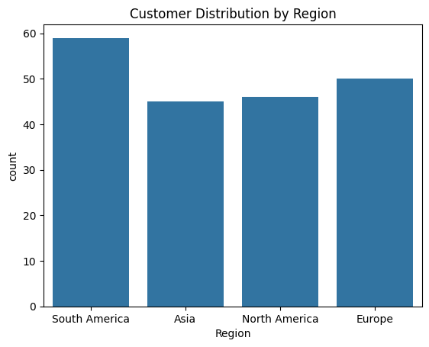

1. **Product Category Popularity:** Certain product categories are more popular than others. Understanding the proportions of each category can inform inventory management, pricing strategies, and marketing campaigns.

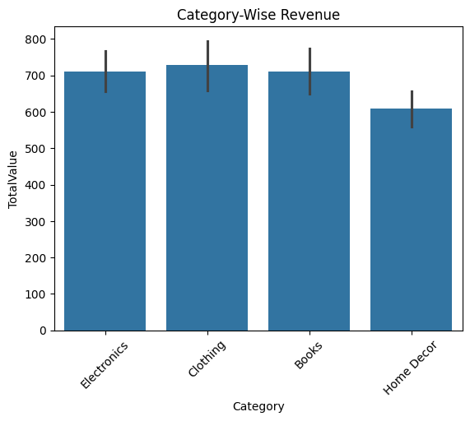

1. **High-Value Transactions and Products:** Identifying the top 10 highest-value transactions and the 5 most expensive products can provide insights into high-profit areas and potential areas for upselling or cross-selling.
2. 5 Most expensive product
3. ProductID ProductName Category Price
4. 74 P075 TechPro Textbook Books 497.76
5. 31 P032 BookWorld Cookbook Books 488.63

44 P045 SoundWave T-Shirt Clothing 481.78

16 P017 ActiveWear Textbook Books 469.77

36 P037 SoundWave Smartwatch Electronics 459.86

**Top 10 highest value transaction**

TransactionID CustomerID ProductID TransactionDate Quantity \

879 T00928 C0082 P075 2024-09-06 18:39:07 4

509 T00499 C0065 P032 2024-07-18 02:51:22 4

971 T00307 C0044 P045 2024-05-30 18:15:28 4

560 T00070 C0051 P017 2024-12-11 13:46:30 4

562 T00224 C0171 P017 2024-07-06 23:53:24 4

565 T00503 C0013 P017 2024-07-26 00:21:59 4

566 T00558 C0169 P017 2024-11-29 23:39:00 4

997 T00922 C0018 P037 2024-04-05 13:05:32 4

118 T00012 C0091 P041 2024-03-29 01:28:17 4

119 T00034 C0168 P041 2024-01-09 11:00:50 4

TotalValue Price

879 1991.04 497.76

509 1954.52 488.63

971 1927.12 481.78

560 1879.08 469.77

562 1879.08 469.77

565 1879.08 469.77

566 1879.08 469.77

997 1839.44 459.86

118 1825.12 456.28

119 1825.12 456.28

4. **Customer Lifetime Value (CLV):**  A significant portion of the total revenue comes from a small number of high-CLV customers.  Focusing on retention strategies for these customers is crucial.

CustomerID price

C0141 10673.87

C0054 8040.39

C0065 7663.70

C0156 7634.45

C0082 7572.91

C0188 7111.32

C0059 7073.28

C0028 6819.57

C0099 6715.72

C0165 6708.10

5.**Monthly Revenue Trends:** Analyzing monthly revenue trends reveals patterns in sales performance over time, which can help in forecasting and identifying potential seasonal effects or anomalies.

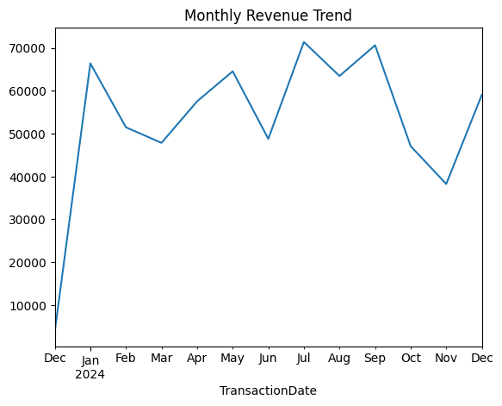

6. **Correlation Between Transaction Variables:** The correlation matrix and heatmap can reveal relationships between numerical variables in the transactions data. For example, there might be a correlation between the quantity purchased and total value.

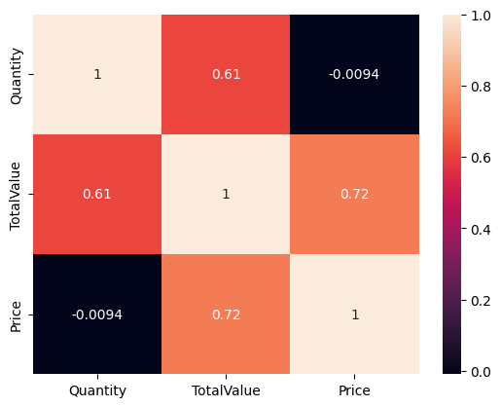

7. **Customer Acquisition Trends:** Examining the number of new customer sign-ups over time provides insights into the success of customer acquisition efforts and can reveal trends or seasonality in customer onboarding.

